Data Visualization – Practical Solutions
Question 1 – Empirical Cumulative Distribution Function (ECDF)
# Q1: ECDF of student marks
library(ggplot2)

marks <- c(45, 52, 58, 60, 65, 68, 72, 75, 80, 90)

# Sort data and compute cumulative probability F(x) = rank/n
sorted_marks <- sort(marks)
n <- length(sorted_marks)
cum_prob <- (1:n) / n
ecdf_table <- data.frame(Marks = sorted_marks, Cumulative_Probability = cum_prob)
print(ecdf_table)

df <- data.frame(marks = marks)

p <- ggplot(df, aes(x = marks)) +
stat_ecdf(geom = "step", color = "steelblue", linewidth = 1) +
geom_point(data = ecdf_table, aes(x = Marks, y = Cumulative_Probability),
color = "darkred", size = 2) +
labs(title = "ECDF of Quiz Marks", x = "Marks", y = "Cumulative Probability") +
theme_minimal(base_size = 13)

ggsave("q1_ecdf.png", p, width = 6.5, height = 4.5, dpi = 200)
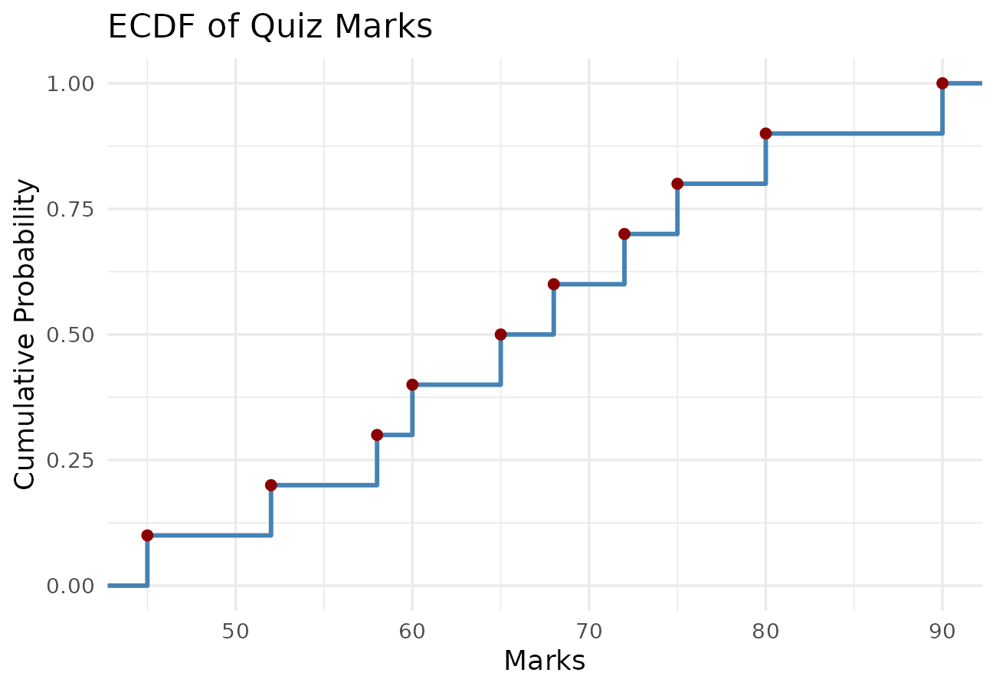
Calculation Table
Student | Marks (sorted) | Cumulative Probability
S1 | 45 | 0.1
S2 | 52 | 0.2
S3 | 58 | 0.3
S4 | 60 | 0.4
S5 | 65 | 0.5
S6 | 68 | 0.6
S7 | 72 | 0.7
S8 | 75 | 0.8
S9 | 80 | 0.9
S10 | 90 | 1.0

The ECDF rises in equal steps of 0.1 since each of the 10 students contributes equally to the cumulative proportion. For example, the probability of scoring at or below 65 marks is 0.5, meaning half the class scored 65 or less. The plot shows no large jumps, so marks are fairly evenly spread across the range 45 to 90 without major clustering.
Question 2 – Empirical Cumulative Distribution Function (ECDF)
# Q2: ECDF of daily steps
library(ggplot2)

steps <- c(4200, 5000, 5600, 6100, 6800, 7200, 8100, 9200, 10400, 12000)

sorted_steps <- sort(steps)
n <- length(sorted_steps)
cum_prob <- (1:n) / n
ecdf_table <- data.frame(Daily_Steps = sorted_steps, Cumulative_Probability = cum_prob)
print(ecdf_table)

# Proportion of participants who walked 8000 steps or fewer
prop_8000 <- mean(steps <= 8000)
cat("Proportion with steps <= 8000:", prop_8000, "\n")

df <- data.frame(steps = steps)

p <- ggplot(df, aes(x = steps)) +
stat_ecdf(geom = "step", color = "darkgreen", linewidth = 1) +
geom_point(data = ecdf_table, aes(x = Daily_Steps, y = Cumulative_Probability),
color = "darkred", size = 2) +
geom_vline(xintercept = 8000, linetype = "dashed", color = "grey40") +
labs(title = "ECDF of Daily Steps", x = "Daily Steps", y = "Cumulative Probability") +
theme_minimal(base_size = 13)

ggsave("q2_ecdf.png", p, width = 6.5, height = 4.5, dpi = 200)
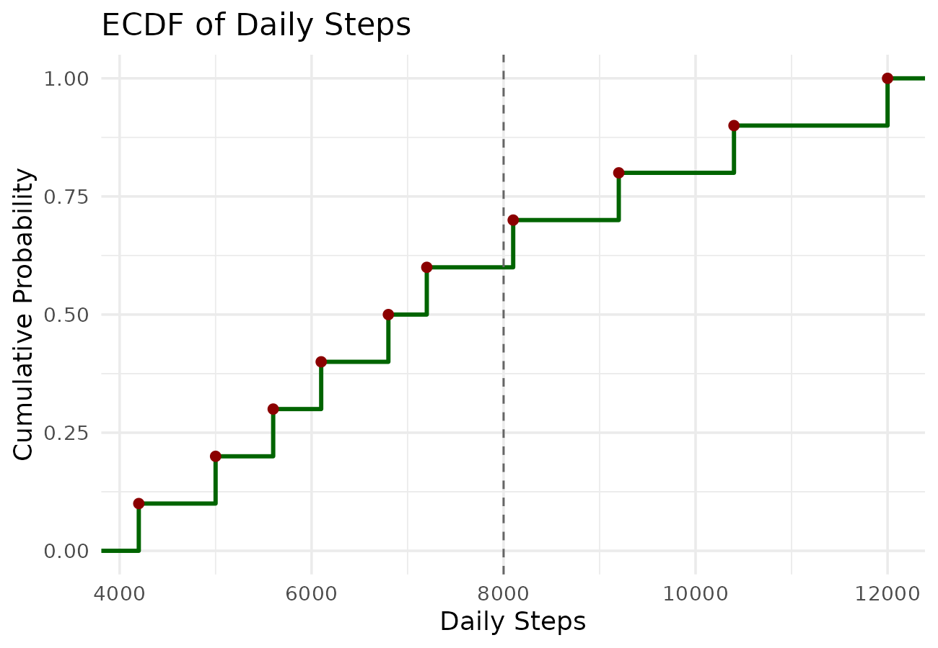
Calculation Table
Participant | Daily Steps (sorted) | Cumulative Probability
P1 | 4200 | 0.1
P2 | 5000 | 0.2
P3 | 5600 | 0.3
P4 | 6100 | 0.4
P5 | 6800 | 0.5
P6 | 7200 | 0.6
P7 | 8100 | 0.7
P8 | 9200 | 0.8
P9 | 10400 | 0.9
P10 | 12000 | 1.0

From the table, 6 out of 10 participants walked 8,000 steps or fewer, so the proportion is 0.6 (the dashed line in the plot marks this point, just before the step at 8,100). The ECDF is significant because it lets us read off the cumulative proportion of participants at or below any step count directly, without assuming a theoretical distribution.
Question 3 – Highly Skewed Distribution (Histogram and Density Plot)
# Q3: Histogram and Density plot of purchase amounts
library(ggplot2)

purchase <- c(250, 300, 320, 350, 380, 450, 520, 650, 1800, 5200)
df <- data.frame(purchase = purchase)

mean_val <- mean(purchase)
median_val <- median(purchase)

# Histogram
p_hist <- ggplot(df, aes(x = purchase)) +
geom_histogram(binwidth = 500, fill = "skyblue", color = "black", boundary = 0) +
labs(title = "Histogram of Purchase Amounts", x = "Purchase Amount", y = "Frequency") +
theme_minimal(base_size = 13)
ggsave("q3_histogram.png", p_hist, width = 6.5, height = 4.5, dpi = 200)

# Density plot
p_dens <- ggplot(df, aes(x = purchase)) +
geom_density(fill = "orange", alpha = 0.5) +
geom_vline(xintercept = mean_val, linetype = "dashed", color = "red") +
geom_vline(xintercept = median_val, linetype = "dashed", color = "blue") +
labs(title = "Density Plot of Purchase Amounts", x = "Purchase Amount", y = "Density") +
theme_minimal(base_size = 13)
ggsave("q3_density.png", p_dens, width = 6.5, height = 4.5, dpi = 200)
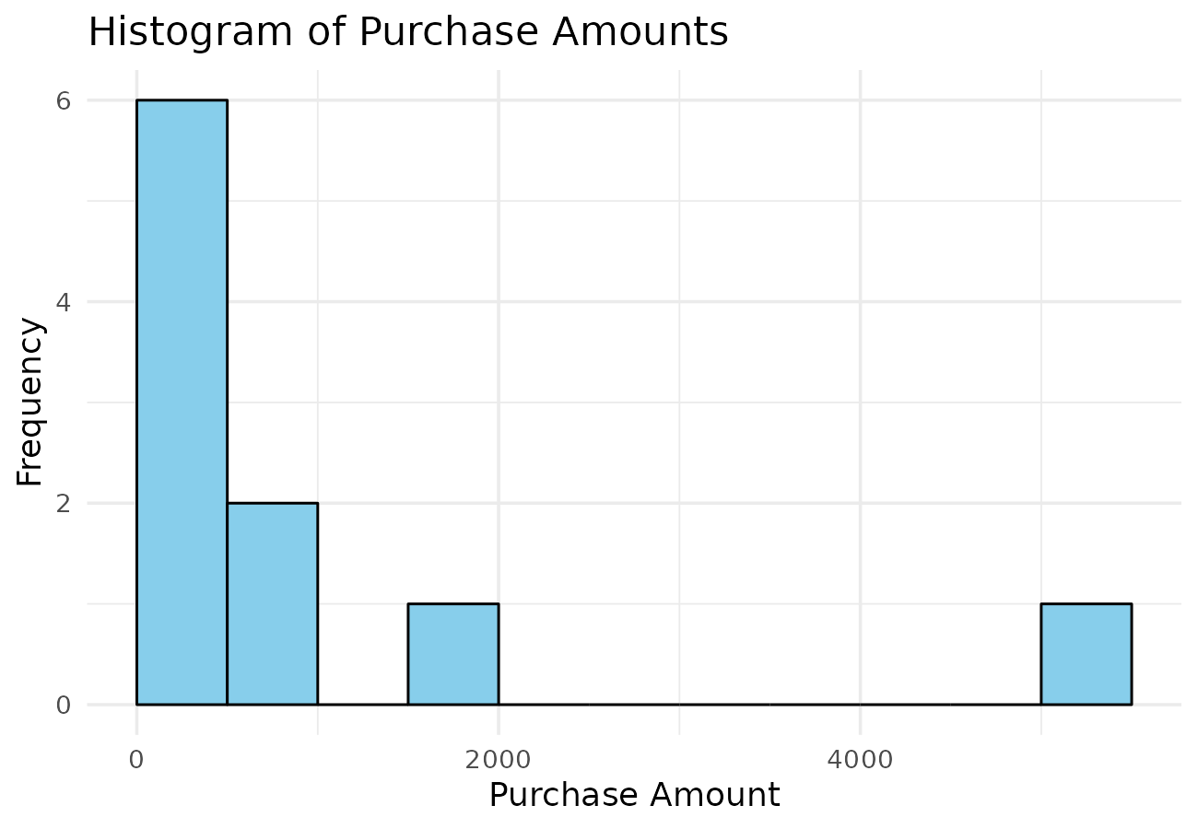
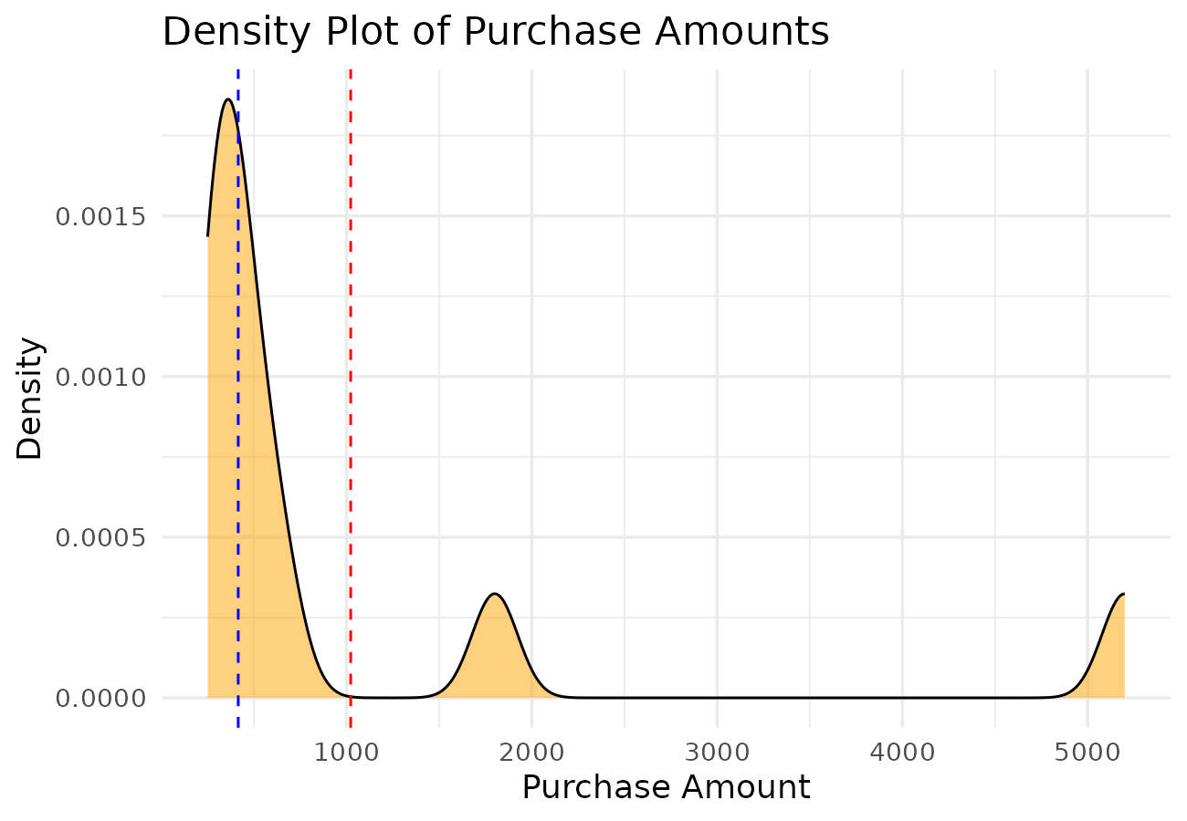
Summary Statistics
Statistic | Value
Mean | 1022
Median | 415

The distribution is positively (right) skewed. Most customers spent between 250 and 650, while two customers (1800 and 5200) made very large purchases, pulling the mean (1022) well above the median (415). The histogram shows a tall cluster of low values with a long thin tail to the right, and the density plot confirms this with a peak near the low values and a stretched right tail.
Question 4 – Quantile-Quantile (Q-Q) Plot
# Q4: Normal Q-Q plot of patient waiting times
library(ggplot2)

waiting_time <- c(12, 15, 18, 20, 22, 24, 25, 28, 30, 32)
df <- data.frame(waiting_time = waiting_time)

p <- ggplot(df, aes(sample = waiting_time)) +
stat_qq(color = "steelblue", size = 2) +
stat_qq_line(color = "red", linewidth = 1) +
labs(title = "Normal Q-Q Plot of Patient Waiting Times",
x = "Theoretical Quantiles", y = "Sample Quantiles") +
theme_minimal(base_size = 13)

ggsave("q4_qqplot.png", p, width = 6.5, height = 4.5, dpi = 200)
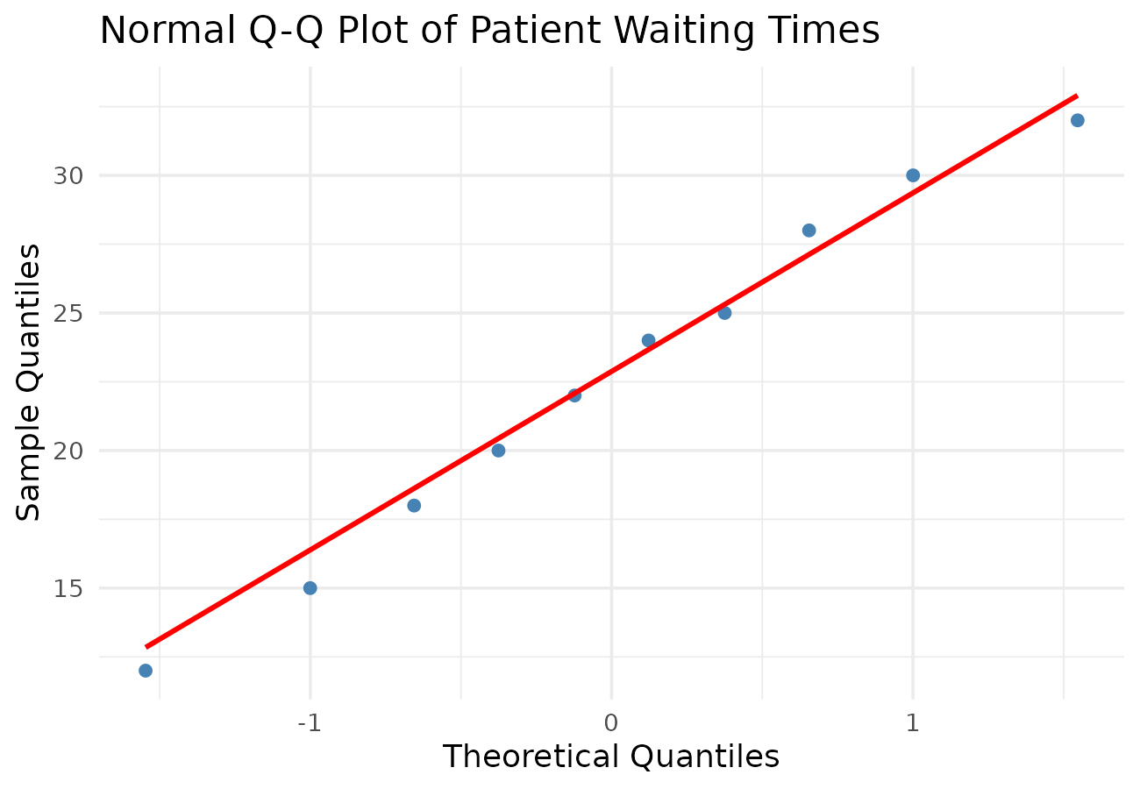
The points in the Q-Q plot lie close to the straight reference line with no strong curvature or outliers. This indicates that the waiting time data approximately follows a normal distribution. A Shapiro-Wilk test on the same data supports this, giving a high p-value (0.96), which means we do not reject normality.
Question 5 – Highly Skewed Distribution and Q-Q Plot
# Q5: Histogram and Normal Q-Q Plot of monthly income
library(ggplot2)

income <- c(18000, 22000, 24000, 26000, 28000, 30000, 34000, 42000, 85000, 200000)
df <- data.frame(income = income)

# Histogram
p_hist <- ggplot(df, aes(x = income)) +
geom_histogram(binwidth = 20000, fill = "lightgreen", color = "black", boundary = 0) +
labs(title = "Histogram of Monthly Income", x = "Monthly Income", y = "Frequency") +
theme_minimal(base_size = 13)
ggsave("q5_histogram.png", p_hist, width = 6.5, height = 4.5, dpi = 200)

# Normal Q-Q plot
p_qq <- ggplot(df, aes(sample = income)) +
stat_qq(color = "steelblue", size = 2) +
stat_qq_line(color = "red", linewidth = 1) +
labs(title = "Normal Q-Q Plot of Monthly Income",
x = "Theoretical Quantiles", y = "Sample Quantiles") +
theme_minimal(base_size = 13)
ggsave("q5_qqplot.png", p_qq, width = 6.5, height = 4.5, dpi = 200)
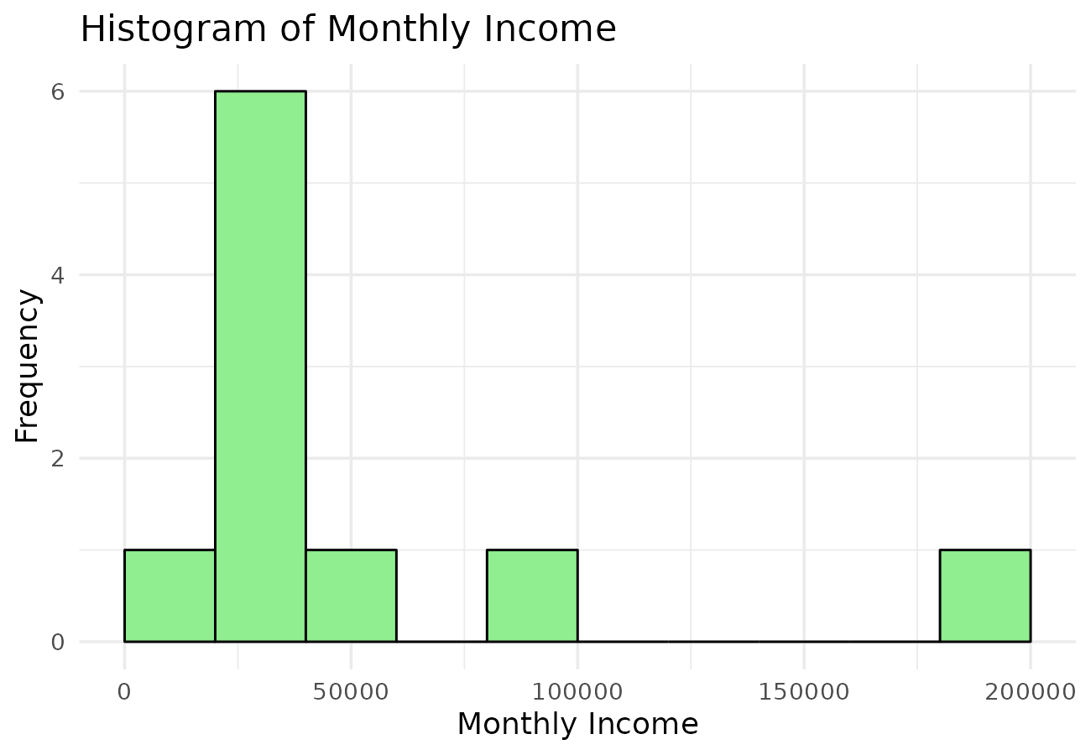
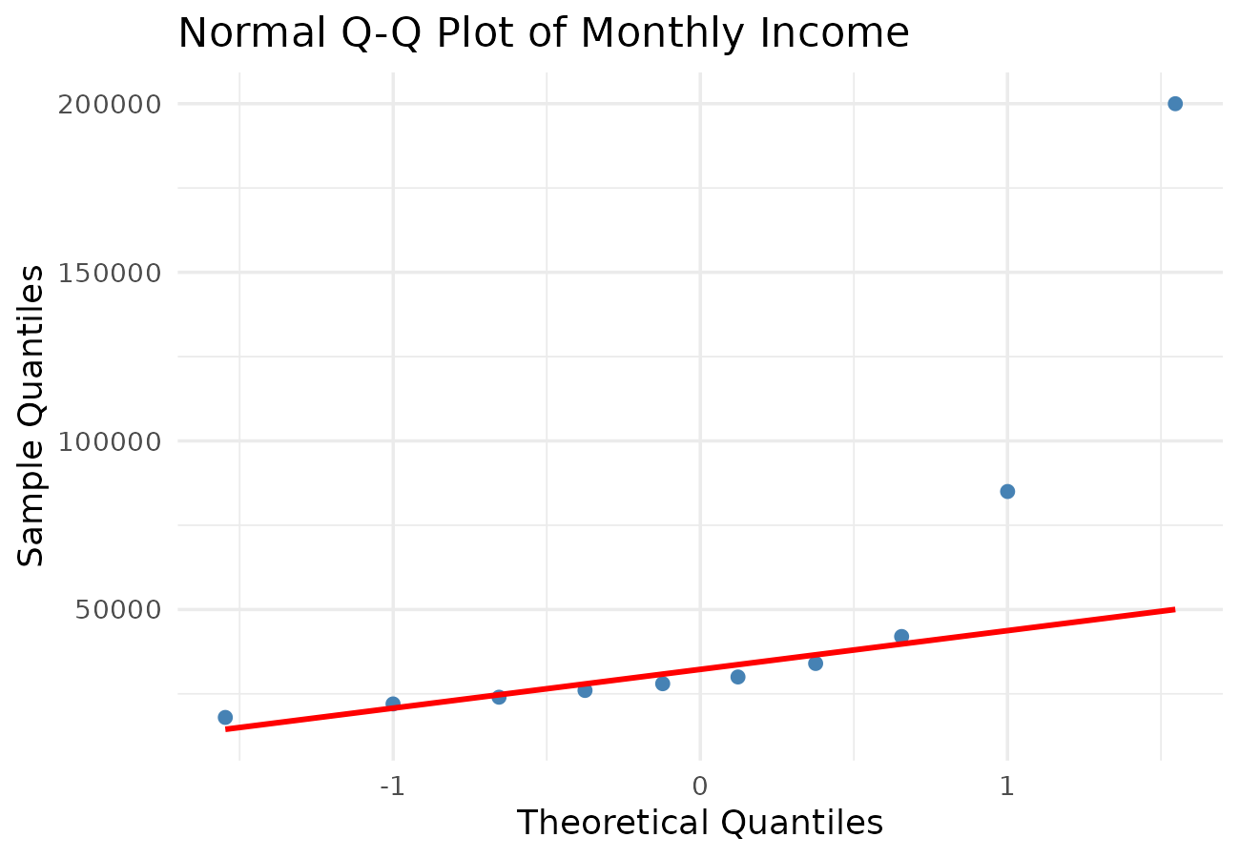
Summary Statistics
Statistic | Value
Mean | 50900
Median | 29000

1. The histogram shows most customers earning between 18,000 and 42,000, with two extreme values (85,000 and 200,000) forming a long right tail.
2. The Q-Q plot is included above; the points curve sharply away from the straight line at the upper end, particularly for the two highest incomes.
3. The income data is highly (positively) skewed, not normally distributed, since the mean (50,900) is far above the median (29,000) and a few customers have exceptionally high incomes.
4. The Q-Q plot supports this because normally distributed data would show points following the diagonal line closely throughout; here the strong upward curve at the right end shows the largest incomes are far more extreme than a normal distribution would predict, confirming the skew seen in the histogram.

